[Title of Project]

at [Name of Parish or Institution]

[City, State of the Parish or Institution]

A capstone project in ministry submitted to the faculty of

Mount St. Mary’s Seminary & School of Theology

in partial fulfillment of the requirements for the [Master of Arts in Pastoral Ministry or Certificate in Pastoral Ministry]

By

[Your First, Middle Initial, Last Name]

Cincinnati, Ohio

[Date]

[this is the date of the completed document; not the graduation date]

Table of Contents

List of Abbreviations (using Heading 1 style) vi

Heading 1 (using Heading 1 style) 1

Heading 2 (using Heading 1 style) 2

2.1 (using Heading 2 style) 2

2.1.1 (using heading 3 style) 2

2.1.2 (using heading 3 style) 3

Heading 3 (using Heading 1 style) 4

3.1 (using Heading 2 style) 4

Bibliography (using Heading 1 style) 5

Did you know that you can create a table of contents (TOC) with one click? It is a two-step process. First use Microsoft Word Styles to apply consistent formatting to your titles, headings, and subheadings; then create a TOC using the References tool in Word. If you are unsure of how to create TOC in Word, please visit Maly Library’s Tutorials at <http://library.athenaeum.edu/tutorials>.

There is already a TOC on this page. You may edit headings in the rest of this document and then update the TOC. To update the page after you have added your own headings, go to References—Update Table. Choose to update the entire table.

After applying Styles, you can also jump to different sections of your paper using View—Navigation Pane (check the box). A navigation pane will appear on the left hand side that allows you to quickly navigate the parts of your report.

Anything that comes after the Contents page should be listed in the table of contents. Therefore, use the heading styles for any heading appearing after the Contents page but not before.

# Heading 1 (using Heading 1 style)

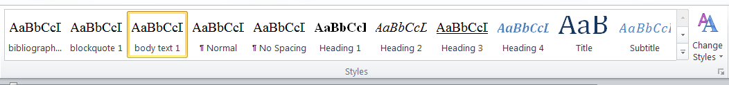 MS Word Styles are very helpful for making your paper look uniform. A number of styles have been created for this template, and we will refer to them where applicable. The styles created for this template may be found in the box at the top of your screen. It looks like this:

The styles for this template can be found by scrolling the up or down arrows (circled) to the right of the style types. Styles are applied at the paragraph level. To apply a style, you must place your cursor in the paragraph where you would like to apply a style, and then click on the style in the style box. Try now to place the cursor here and click on **blockquote 1**. This paragraph will be formatted as a block quote. To return to a style appropriate to the body of this text, keep the cursor in this paragraph and click on **body text 1**.

# Heading 2 (using Heading 1 style)

Major headings should start on a new page. Rather than hitting Enter several times, use Page Layout—Page Break to start a new page. You can see where page breaks, spaces, tabs, and other such hidden formatting marks are by clicking on the paragraph button, found in the MS Word ribbon at top; it is circled in red below:

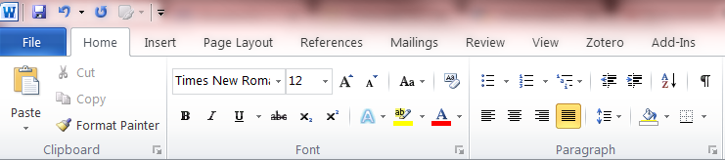

Knowing how to “see” these hidden formatting marks is helpful for figuring out why your paragraphs or spacing may look askew or other formatting problems.

## 2.1 (using Heading 2 style)

This is an example of a subheading. Subheadings may be labeled by name or number. Besides a change in formatting (bold, italics, or underlining), adding a space before the subheading can help set it apart. Unlike headings or chapters, they can be on the same page as headings and other subheadings and do not need to start on a new page. Subheadings do not need to go on a new page unless they are “orphaned,” i.e., the last line on a page. If orphaned, use Page Layout—Page Break to start the subheading on a new page. Try it with the subheading below.

### 2.1.1 (using heading 3 style)

Headings and subheadings can be formatted as you see fit, as long as they are consistent. We have provided an example here of how to format three levels of headings and subheadings. Turabian advises writers to use no more than three subheadings if possible. Numbering them may also help the reader to know where they are in your writing.

### 2.1.2 (using heading 3 style)

Here are a few tips to avoid common mistakes.

A. Periods and commas go inside closing quotation marks.

*Examples*: He yelled, “Hurry up.”

The sign said, “Walk,” then, “Don’t Walk.”

B. Use single quotation marks for quotations within quotations.

*Example*: Topping states that “Augustine never considered happiness to be something attainable outside of the workings of grace. Only God can be happy by his own power: ‘For the nature of man did not receive the power of being happy on its own without God ruling it.’”[1]

C. Always write out dates (January 1, 2018). Do not use numeric form or European form.

# Heading 3 (using Heading 1 style)

Quotes may be integrated into your text in two ways—three or fewer lines can be in the body of your text with quotation marks; any quote that takes up four or more lines ought to be set off as an indented block without quotation marks. The following uses **blockquote 1** style:

Readers . . . expect you to cite the source for an idea when (1) the idea is associated with a specific person *and* (2) it’s new enough not to be part of a field’s common knowledge. . . . [Therefore] cite a source for an idea not your own whenever an informed reader might think you’re implying that it is your own. Though that seems black and white, it has a big gray area in the middle. When in doubt, check with your instructor.[2]

Be sure to introduce quotes and use only what you need, whether as a quote, paraphrase, or summary. Also be sure to explain to the reader why you are using the quote—do not expect it to stand on its own.

## 3.1 (using Heading 2 style)

The footnotes have a footnote style applied already.

# Bibliography (using Heading 1 style)

Benedict XVI. The Apostles and Their Co-Workers: The Origins of the Church. Huntington, IN: Our Sunday Visitor, 2010.

——— [Ratzinger, Joseph Cardinal]. *Behold the Pierced One: An Approach to a Spiritual Christology*. San Francisco: Ignatius Press, 1986.

——— [Ratzinger, Joseph Cardinal]. “Letter to Bishops of the Catholic Church on Certain Questions Concerning the Minister of the Eucharist.” Vatican Website, August 6, 1983. Accessed March 20, 2015. http://www.vatican.va/roman_curia /congregations/cfaith/documents/rc_con_cfaith_doc_19830806_sacerdotium-ministeriale_en.html.

Kasper, Walter Cardinal. “On the Church.” *America* 184, no. 14 (April 23, 2001): 8–14.

Lapple, Alfred. *Key Problems of Genesis*. Glen Rock, NJ: Paulist Press, 1967.

Metzger, Bruce M. “Introduction to the New Testament.” In *The New Oxford Annotated Bible with the Apocrypha*, edited by Herbert G. May and Bruce M. Metzger, 1–5. New York: Oxford University Press, 1977.

Ratzinger, Joseph Cardinal. See Benedict XVI.

Second Vatican Council. *Dei verbum [Dogmatic Constitution on Divine Revelation].* Vatican Website, November 18, 1965. Accessed December 5, 2013. http:// www.vatican.va/archive/hist_councils/ii_vatican_council/documents/vat-ii_const _19651118_dei-verbum_en.html.

Seewald, Peter, and Joseph Cardinal Ratzinger. *Salt of the Earth: The Church at the End of the Millennium- An Interview With Peter Seewald*. Translated by Adrian Walker. San Francisco: Ignatius Press, 1997.

Entries should be listed alphabetically by surname and then by title if the author has more than one title. If you have a large number of different types of sources, you may choose to group like items together in a bibliography such as primary sources and secondary sources. The items above are formatted with **bibliography 1** style.

1. “Non enim accepit hominis natura, ut per suam potestatem deo non re-gente beata sit” (*De Genesi adversus Manicheos* 2.15.22; *Corpus Scriptorum Ecclesiasticorum Latinorum* 91.144), translated in Ryan N. S. Topping, *Happiness and Wisdom: Augustine’s Early Theology of Education* (Washington, D.C.: Catholic University of America Press, 2012), 78.
2. Kate L. Turabian, *A Manual for Writers of Research Papers, Theses, and Dissertations: Chicago Style for Students and Researchers*, 8th ed. (Chicago: University of Chicago Press, 2013), 81.